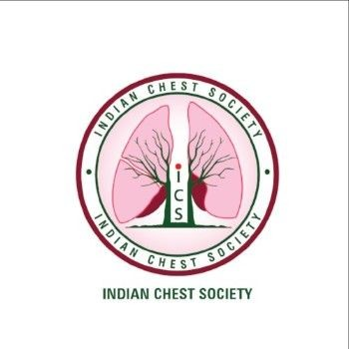

**INDIAN CHEST SOCIETY**

**APPLICATION FORMAT FOR AWARD OF FELLOWSHIP (FICS)**

(Format can be downloaded at the ICS website. Application should be prepared with MS word and sent to the ICS Office in PDF Format within the last date of Submission)

**Name of the Nominee**: **……………………………………………………………………**

**Membership No**.**: ……………………….. Date of Birth:…………………… Sex:..……**

**Communication Address:**

**1. Educational Qualifications:**

|  |  |  |
| --- | --- | --- |
| **Medical Qualification** | **University/Institution** | **Qualifying Year** |
|  |  |  |
|  |  |  |
|  |  |  |
|  |  |  |
|  |  |  |

**2. Teaching and/or Professional Experience to date**

|  |  |  |  |
| --- | --- | --- | --- |
| **Sr. No** | **Designation** | **Hospital** | **Period**  **From - To** |
|  |  |  |  |
|  |  |  |  |
|  |  |  |  |

**3. Publications enclosed**

**A. Number of Publications (Please provide a complete list in annexure for each group mentioned below)**

|  |  |  |  |  |
| --- | --- | --- | --- | --- |
| **Type** | **Indexed Journals or Lung India** | | **Other Journals** | |
| **First or Corresponding**  **Author** | **Other authorship** | **First or Corresponding**  **Author** | **Other authorship** |
| Original Research |  |  |  |  |
| Case reports |  |  |  |  |
| Reviews & Editorials |  |  |  |  |
| Letters & Others |  |  |  |  |

**B. Chapters in Books.**

**C. Books and Monographs**

**4. Awards of Professional Recognition (Specify the name(s) of the Award(s) with year**

**5. Representation in International / National Organizations / Committees / Bodies / Institutions**

**6. Role in ICS/International Respiratory Societies with year(s) of serving**

**7. Any Other Information**

**8. Verification**

I the undersigned hereby affirm and declare that the information given above is true to the best of my knowledge and nothing has been concealed or overstated there-in. I further declare that I have never been indicted in professional/academic misconduct and no such complaints or proceedings are pending against me. I also understand that the ICS has the right to withdraw fellowship and take disciplinary action amounting to suspension/expulsion from the society if at any stage the claims made by me are found to be untrue or false.

**Date:**

**(Signature of the applicant)**